Lab Exercise -7: Queue Data Structure Implementation using Array and Linked Lists and Applications of Queue ADT

Experiment 1: Linear Queue using Array
Objectives:
• Implement a simple linear queue.
• Perform enqueue, dequeue, peek, isEmpty, and isFull operations.

Tasks: 1. Define an array queue[MAX] and variables front and rear. 2. Implement enqueue operation with overflow check. 3. Implement dequeue operation with underflow check. 4. Implement peek/front operation. 5. Implement display function to show all elements. Expected Outcome: • Students will understand FIFO behavior and the limitations of linear queue (space wastage). 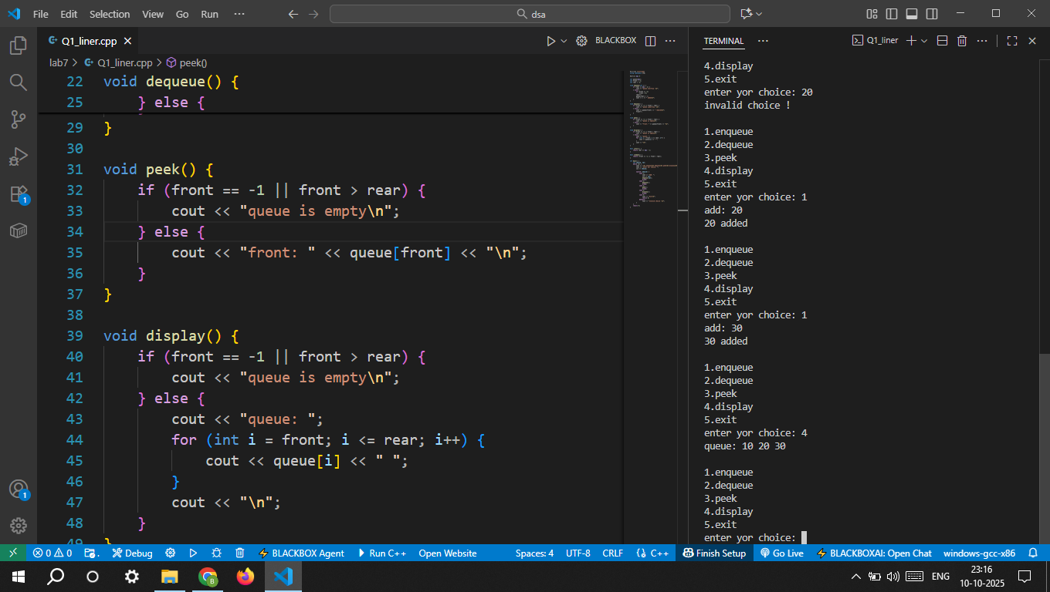

Experiment 2: Queue using Linked List
Objectives: • Implement a queue using singly linked list. • Understand dynamic memory allocation and pointer management
Tasks:
1. Create a node structure with data and next. 2. Implement enqueue at the rear. 3. Implement dequeue at the front. 4. Implement peek operation. 5. Display queue elements.
Expected Outcome: • Queue size can grow dynamically. • Students will understand difference between array-based and linked-list queue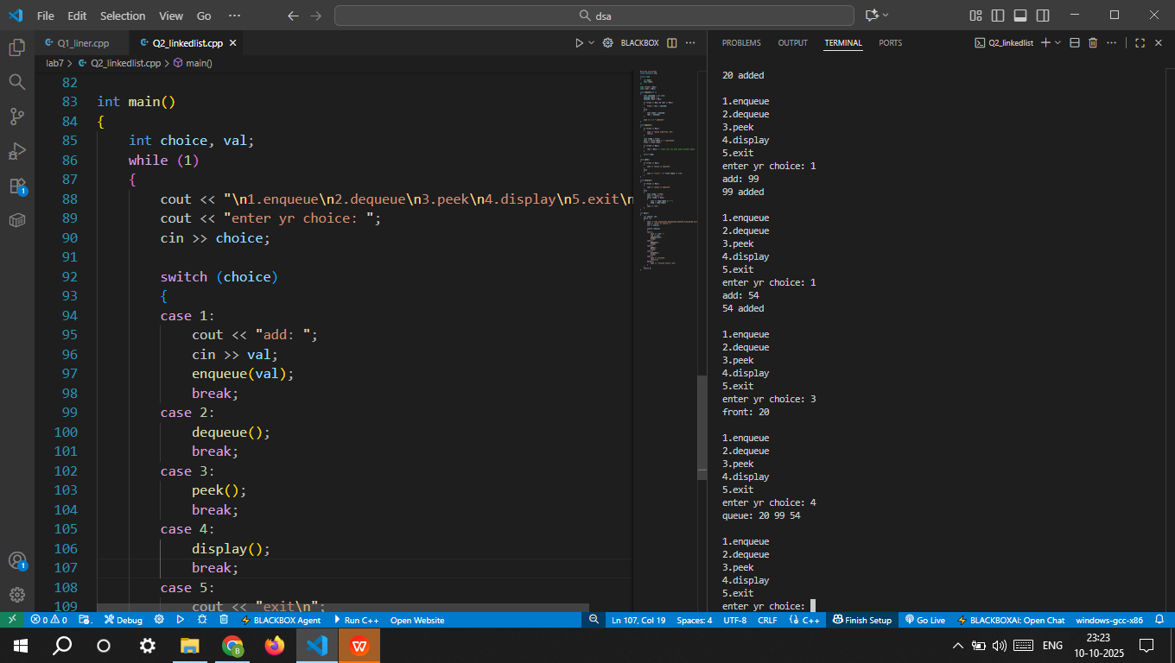

Experiment 3: Circular Queue using Array
Objectives:
• Implement a circular queue to overcome the wastage of linear queue.
Tasks:
1. Define array cq[MAX], front, and rear. 2. Implement enqueue with circular increment (rear + 1) % MAX. 3. Implement dequeue with circular increment (front + 1) % MAX. 4. Implement display function handling circular nature.
Expected Outcome:
• Efficient memory utilization in queues. • Understand modulus operation for circular behavior.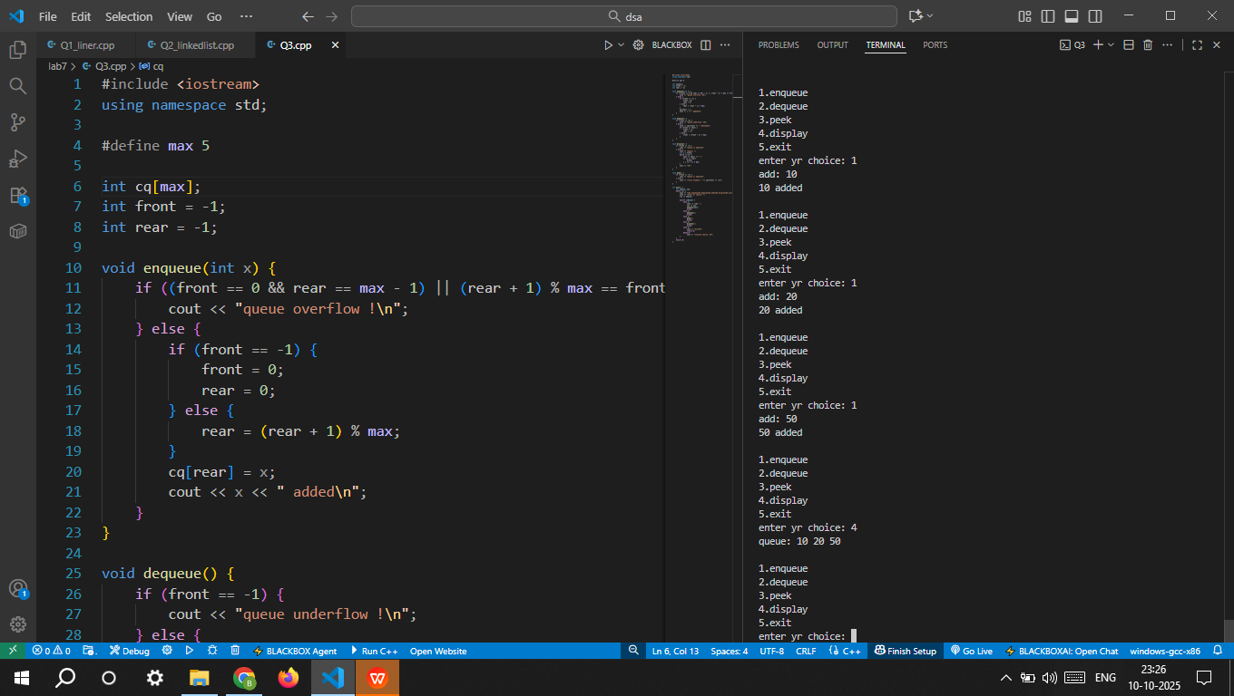

Experiment 4: Double-Ended Queue (Deque)
Objectives: • Implement deque using array. • Insert and delete elements from both ends.
Tasks: 1. Define front and rear pointers. 2. Implement insertFront, insertRear, deleteFront, deleteRear. 3. Display queue elements after each operation.
Expected Outcome: • Students will learn flexible queue operations. • Real-world analogy: Undo/Redo stack in editors.
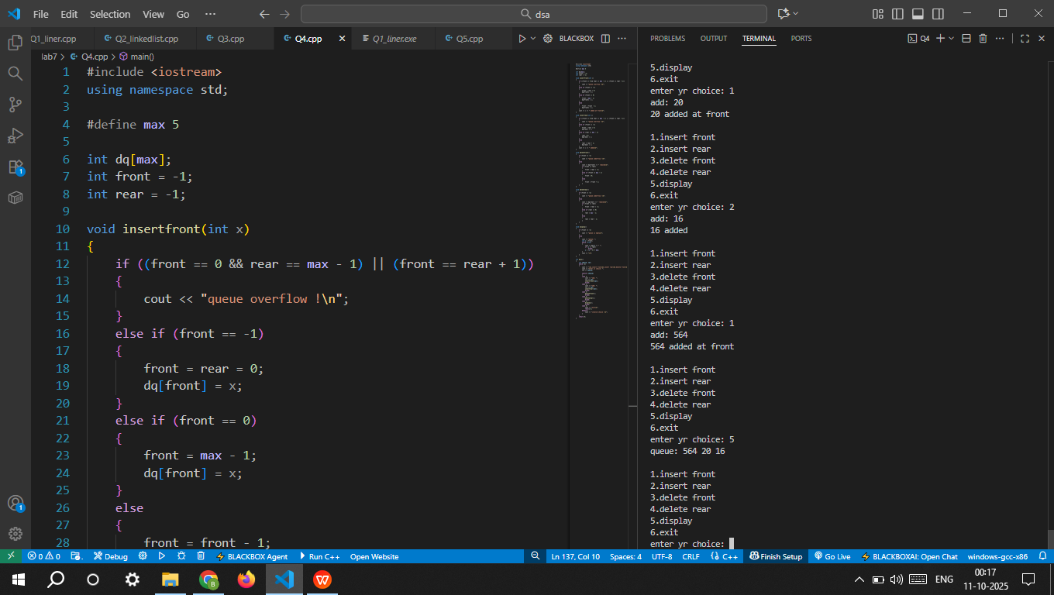

Experiment 5: Priority Queue using Array
Objectives: • Implement a priority queue using array. • Understand priority-based element selection. Tasks: 1. Define an array of Element {data, priority}. 2. Implement enqueue (unsorted array → O(1)). 3. Implement dequeue (find highest priority → O(n)). 4. Implement peek operation. 5. Display queue with priorities. Expected Outcome: • Understand priority scheduling, like CPU or OS jobs. • Compare unsorted vs sorted array implementation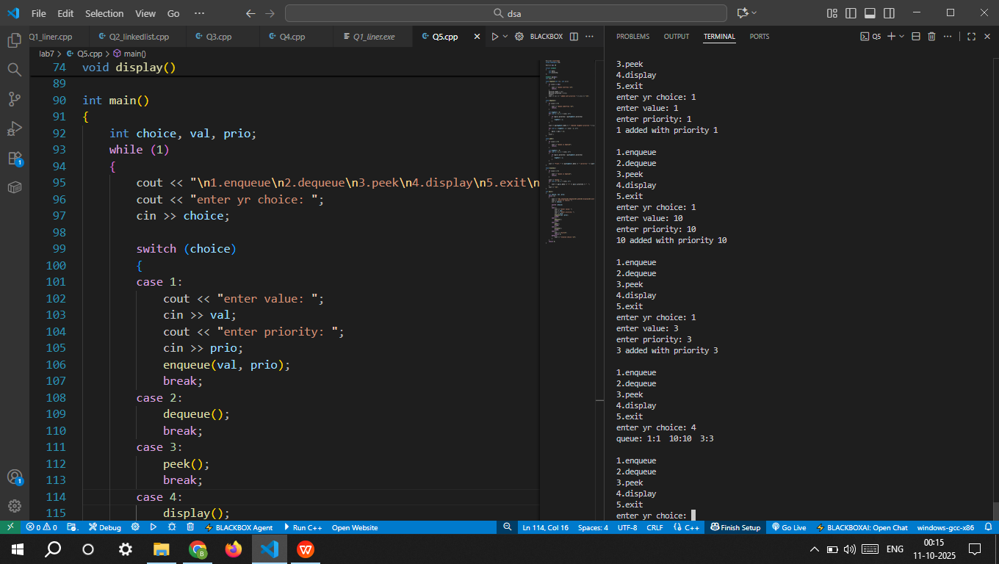

Experiment 8: Multiple Queues in a Single Array
Objectives: • Implement two queues in one array. • Efficient memory usage by sharing array space.
Tasks: 1. Define arr[MAX], front1, rear1, front2, rear2. 2. Queue1 grows left → right, Queue2 grows right → left. 3. Implement enqueue and dequeue for both queues. 4. Display elements of both queues.
Expected Outcome: • Learn memory-efficient queue design. • Understand overflow conditions for multiple queues.
